CS/CE/SE 3354.004: Software Engineering

Final Project Deliverable 1

Meal Recipe Database

Siddharth Vadlamani

Yashal Saleem

Han Nguyen

Charles Kumets

Aggie Lam

Toan Tran

Aidan Gow

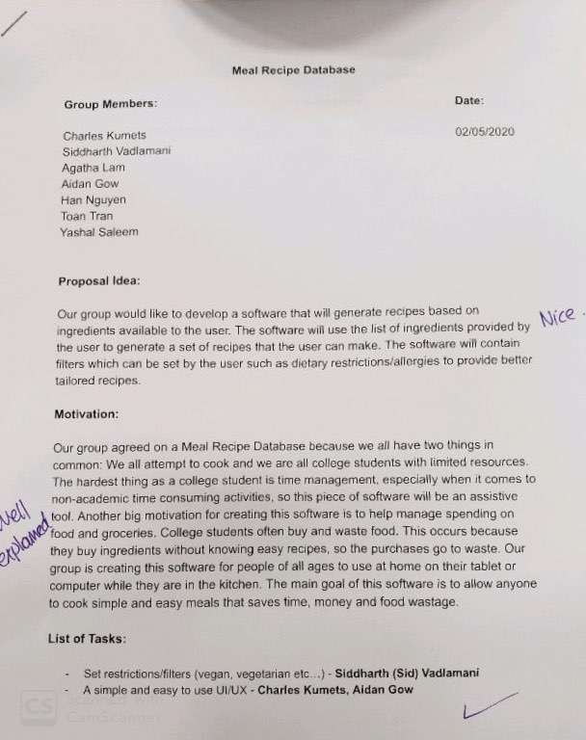

**Feedback provided:**

We did not need to make any changes based on the feedback provided.

**Software process model: (Group)**

Incremental process model because we can build on to the database whenever there are more provided recipes/features.

**Software Requirements: (Yashal Saleem)**

Functional requirements:

* A user can input ingredients
* A user can add new recipes as well as save/favorite recipes.
* A user will receive a recipe based on ingredients.
* A user can create an account or login.
* A user can view/add comments under specific recipes.
* A user can like/dislike recipes (rating).
* A user can search for recipes. (with tags)

Non Functional Requirements:

* Usability Requirements:
  + - Should work on multiple platforms
    - Should be accessible online and somewhat offline for users.
    - Clear directions so that users can use software to full potential.
* Performance Requirements:
  + - User inputs ingredients and outputs
    - Available on android/IOS
    - Programing languages include Swift(IOS), Java(android)
    - Database = Sequel (Server)
* Space Requirements
  + - For the layered architecture the main recipe data will be held in one layer
    - Space for the user submission should be a set maximum they’ll be able to reach.
    - Space for storing all the submitted recipe data in general will be manipulated dynamically.
* Dependability Requirements
  + - Should be able to use some functions offline to a certain extent.
    - Space for saved recipes should be large and then restrict when reaches full capacity.
    - The allocation for the recipes will be dynamic so that more can be continuously added overtime without it breaking the system.
* Environmental Requirements
  + - The project will try not to push the limits of the system, most especially when it comes to storing data.
    - The different components used in the environment will be done based on how essential they are to the project. Otherwise we will end up increasing complexity and have poor performance.
* Operational Requirements
  + - The database should be able to hold onto a lot of data and still be able to function at almost the same speed if there wasn’t a lot of data.
    - The time for lookup of the recipes in the database should be very low and not increase by a lot if the size of the database increases.
    - Commenting and adding recipes should be updated in a very short time when submitted, with the chance to edit what has already been posted as well.
* Development Requirements
  + - The development process will consist of taking small steps with versions that will improve overtime so that it doesn’t get too overwhelmed at the beginning.
    - Testing for each feature will occur and every test case needs to be satisfied before moving onto the next step in the process.
    - Each feature and changes done in each version will be clearly documented and explained.
* Regulatory Requirements
  + - The project will follow the required security regulations needed when it comes to storing user data like this.
    - Transparency in how the data will be used and held will be clear since that's an important regulation that needs to be followed.
* Ethical Requirements
  + - It will be made sure that any user information that isn’t explicitly mentioned to be public will not be shared.
    - It will be made explicitly clear to the users what information they post can be used for. This is for both in-app usage and out of app usage of the data.
* Accounting Requirements
  + - Money and resources put into this project and divided into it will be clearly outlined and transparent.
    - Profit from this project will first take into the account of reinvesting some of it to further improve the project.
* Safety/Security Requirements
  + - Sensitive user data will be encrypted.
    - Precautions will be done to try to limit how much sensitive information a user may unknowingly leak to other people.
    - Ways to reset password and provide backup ways to login if the user loses access to the account via the normal method.

**Use Case Diagram: (Aidan Gow)**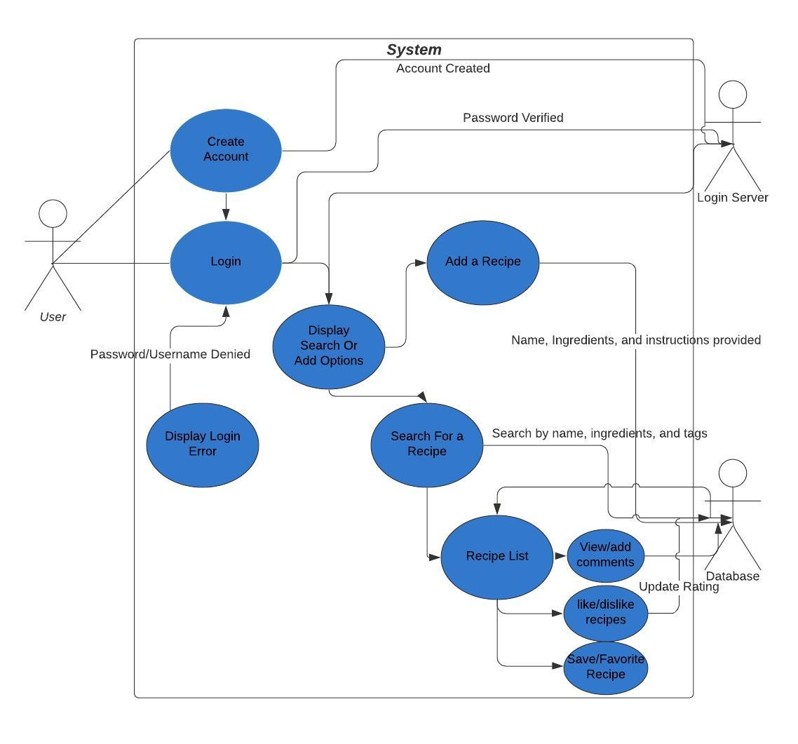

**Architectural Design: (Aggie Lam)**



For this project, our team decided that a layered architecture pattern would fit our software the best. The accompanied diagram depicts each of the 4 layers and the services that would be implemented in each.

To briefly explain the services, the UI layer will consist of two interfaces for the different types of OS's that will the mobile application will be available for, iOS and Android.

The configuration services layer contains the identity management services that will allow a user to create their account, login/out, reset their password, etc. It will also have application management services that manages the creation and message boards and any offline contents users have in their app.

The business logic layer consists of the recipe collection, with each recipe, its ingredients, creator, rating, and any tags. Also, in this layer will be the list of favorite recipes of each user and users' comments on the recipes. The search functionality (searching by ingredients, name, and other filters) that this app is based on will also be implemented in the business logic layer.

The system support layer will be responsible for user authentication and encrypting users' passwords, as well as managing the database that will hold the recipes. Additionally, this layer will control the activity logs and system alerts, and provide support for the storage devices, making sure they are of enough capacity.

**Sequence Diagram: (Toan Tran & Charles Kumets)**

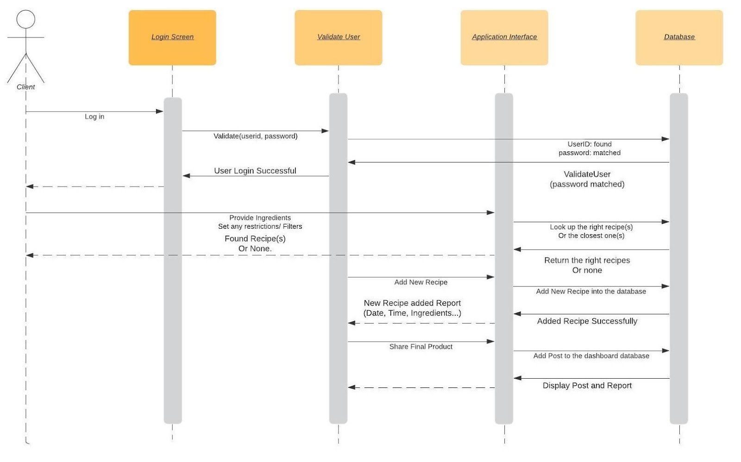

**Class Diagram: (Siddharth Vadlamani & Han Nguyen)**

